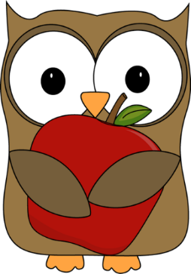

**A note from Mrs. O’Hearn:**

I cannot believe September is almost over! Our first month of school has been both busy and lots of fun. I am truly enjoying getting to know each student in kindergarten and am so proud of the community we have formed in our classroom. If you ever have any questions or concerns, or just want to chat about how your child is doing, please contact me by phone or email. I hope you have a wonderful weekend!

**Kindergarten News**

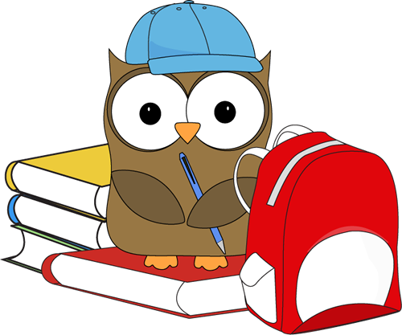

**Important reminders:**

* We have a **morning and afternoon snack.** Please send your child with something for each snack ☺ I will help remind students to save food for our last snack of the day. Please let me know if you have any questions or concerns.
* **Family photos:** I have only received a few family photos. If you would like to send one in, I am creating a display in the classroom. Photos will be returned at the end of the school year.
* **Dismissal changes: Please send a note and/or call the office**

**Upcoming dates:**

* Oct 3- PTO meeting, 6:00pm
* Oct 9- Discovery Day (No School)
* Oct 16- Mugs n Muffins with Principal Kat Crosby (see flyer that went home for more info)

**What we’ve been learning this week:**

**Reading:** Our letters of the week were i and u. Students completed a variety of centers to help them practice identifying these letters and their sounds. Students are also working on responding to books they have read (by looking at the pictures). They are learning how to draw the beginning, middle, and end of a story.

**Writing:** We began Writer’s Workshop this week, which is part of our afternoon on most days. Students learned how good writers add details and lots of color to their pictures, and how writers write about what they know. I am so impressed with the progress students have made with their drawings in just one short week!

**Math:** We are wrapping up our first topic in math- classifying and sorting objects in a variety of ways. Students have played math games, talked with partners, completed cut and paste sorts, and sorted objects on our interactive whiteboard. We have a calendar routine every afternoon as well, and do lots of counting!

**Science:** Our first topic in science is weather. We graph our weather every day and are starting to learn about different words to use to describe weather. Students did a great job sorting articles of clothing based on the weather they are worn in.

**Social Studies:** We are continuing to discuss and practice classroom/school rules and expectations. Students are also great at giving examples of how to treat others with kindness and respect.