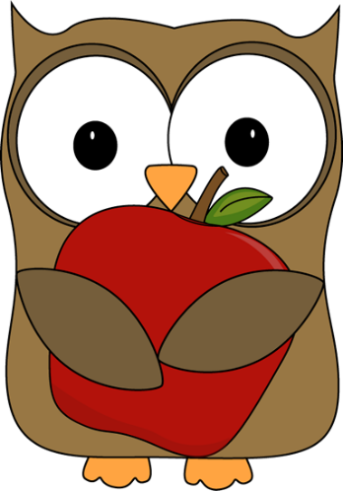

**Kindergarten News**

**A note from Mrs. O’Hearn:** Hello families! It is finally starting to feel like autumn. We enjoyed spending some extra time outside this week to enjoy this beautiful weather. We have been busy in our classroom as well! I am truly enjoying seeing students’ enthusiasm for learning and confidence in their own skills and abilities increase. We have an amazing, caring community of learners in our classroom, and I feel very lucky to be part of your child’s kindergarten year. I hope you have a great weekend!

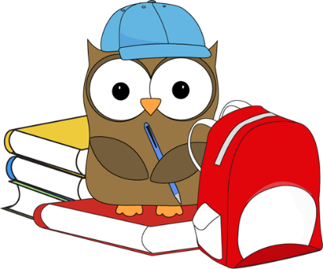

**Upcoming dates:**

-**Kindergarten Mugs ‘n’ Muffins with Mrs. Crosby-** Monday, October 16, 9:00-9:45, MES Library

**-Halloween parade-** Tuesday, October 31, 10:00 (Costumes can be worn, but no weapons or gore please! Families are welcome to attend. More info coming soon!)

**-Kindergarten Halloween celebration-** Tuesday, October 31, 12:00-2:00 (Please let me know if you would like to attend and/or donate a drink or snack!)

**Important reminders:**

Because K students have been so responsible during Library, they are now able to take their checked out books home! ☺

**Our library day is Tuesday.** Library books checked out the previous week should be returned the following Tuesday.

**What we’ve been learning this week:**

**Reading:** Our letters of the week were Aa and Gg. Students have learned 4 vowel sounds and are practicing all sounds (vowels and consonants) every day. We have read lots of rhyming books this week, and students are beginning to identify and produce rhymes on their own. I also introduced our third sight word, like.

**Writing:** Writer’s Workshop is many students’ favorite part of the day! This week, we worked on labeling parts of our drawings by writing the beginning sound we hear (i.e. writing “t” next to a drawing of a tree). I am consistently impressed by the amount of detail students are adding to their work!

**Math:** In math, our focus this week was finding “hidden partners” inside bigger numbers. For instance, the hidden partners inside the number 5 are: 2 and 3, and 4 and 1. We are also continuing to work on putting numbers in order, number formation, and counting sets of objects.

**Science:** We continued our work with weather this week. We discussed which months are in which of the 4 seasons, and students worked with partners to put the 4 seasons in the correct order. Students also completed the first entry in their weather journals.

**Social Studies:** Students are doing an amazing job following classroom and school expectations! During our Closing Circles, students often share a good choice they made during the day or give a compliment to a friend who was following expectations.