

**Kindergarten News**

**A note from Mrs. O’Hearn:**

It has been a long time since my last newsletter! I hope you have had a good October and November- it’s hard to believe December is already here! We have become even closer as a classroom community and I am continuously amazed at students’ progress both academically and socially. I am especially excited to start meeting with students in reading groups after the New Year! As always, if you have any questions or concerns, please do not hesitate to call or email me. Have a wonderful weekend!

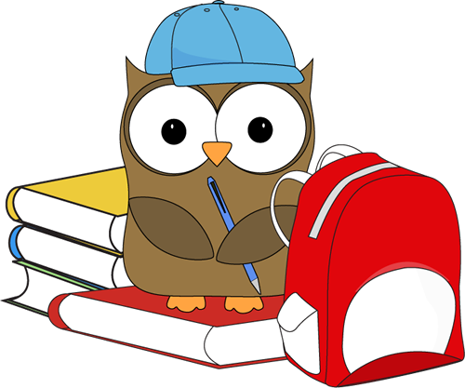

**What we’ve been learning this week:**

**Reading:** We are almost finished learning all of the major 26 letter sounds! I am so impressed with students’ motivation to practice their sounds. We are starting to work on identifying the medial and ending sounds of words, in addition to beginning sounds.

**Writing:** Writer’s Workshop continues to be a favorite part of the day for many students. Students recently began working with a writing partner to help them make their work the best it can be. We will begin working on opinion writing this month!

**Math:** We are continuing our work with numbers 0-10. Students are becoming proficient in decomposing, comparing, and writing these numbers. We also work with shapes and patterns frequently. Our next major topics in math will include measurement, weight, and length.

**Science:** We are wrapping up our science unit on weather. Most students have completed 3 entries in their weather journals, and we have been discussing how the weather has changed since the beginning of the year! We also had our first afternoon of Gardening Club with our friends in second grade. We planted some bulbs and learned about what plants need to grow. Thank you to Amy Gardner for making Gardening Club possible!

**Social Studies:** Throughout the month of December, we will be learning about different holiday traditions in our own families and around the world.

**Upcoming dates:**

**-12/5:** PTO meeting- 6:00  
**-12/9:** Breakfast with Santa @ MES- 9:00  
**-12/12:** Winter concert- 6:00  
**-12/18:** School-wide Meeting- 8:45  
**-12/23-01/01:** No School

**Important reminders:**

* **Exciting news-** **our iPads are finally up and running!** I cannot wait to share all of the cool apps we have for learning with the class. Earbuds are proving very tricky for students’ small ears. I do have some **over the ear headphones**, but any **donations** of these would be greatly appreciated! Thank you so much.
* Students should be bringing a warm coat, hat, and mittens and/or gloves to school daily. When there is a significant amount of snow on the ground, snow pants and boots are needed. Please let me know if you need assistance obtaining any of these items!